
SCHOOL OF ELECTRICAL ENGINEERING & COMPUTER SCIENCE (SEECS)
Computer Vision
By Sara Saqib, Ayaz Akhtar, Shaiza
A Real-Time Chaotic Image Encryption Model on NVIDIA Jetson Nano

Table of Content

1. Abstract 2
2. Introduction 2
3. Background Study 2
4. Feasibility 4
5. References 4

Figures

Figure 1- Chaotic Encryption Framework 2
Figure 2-Project Feasibility Framework 3

1. Abstract

This research proposes an AI-enhanced chaotic image encryption framework for real-time security on the NVIDIA Jetson Nano. The system combines multi-map chaotic algorithms, adaptive key generation, and GPU-based parallel processing to achieve high-speed, high-entropy encryption. It addresses the current gap between chaotic key adaptation and Jetson-based real-time deployment. The model aims to enhance image protection for smart cities, telemedicine, and surveillance.
Keywords: Chaotic Encryption, Jetson Nano, Real-Time Security, Adaptive Key Generation, GPU Optimization

2. Introduction

With the growing reliance on real-time image transmission in surveillance, healthcare, and IoT systems, ensuring image security at the edge has become critical. Traditional encryption algorithms, though secure, are computationally heavy and unsuitable for low-power embedded devices. Chaotic image encryption offers an efficient alternative by utilizing nonlinear and highly sensitive chaotic maps to generate unpredictable encryption patterns.
The NVIDIA Jetson Nano, with its CUDA-enabled GPU, provides a compact yet powerful platform to implement such algorithms in real time. Leveraging GPU parallelism, chaotic encryption can achieve both high speed and strong security on resource-limited hardware. This project aims to design and evaluate a real-time chaotic image encryption framework on the Jetson Nano, combining chaos theory with GPU acceleration to enhance data confidentiality for edge computing applications.
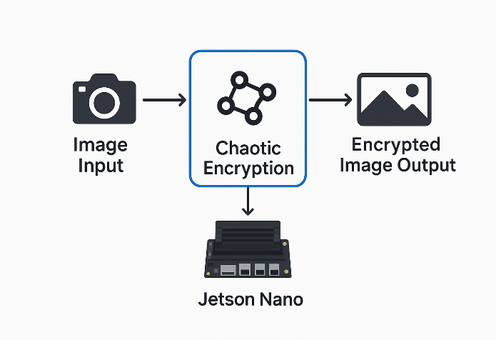
Figure 1- Chaotic Encryption Framework

3. Background Study

The convergence of chaos theory and embedded GPU computing has emerged as a key area of innovation for real-time image encryption. This development is fuelled by the growing demand for low-latency, high-throughput protection of visual data at the edge. Due to their sensitivity to initial conditions, nonlinear attractors, and pseudo-random behaviour, chaotic systems are well suited for lightweight confusion diffusion cryptographic designs. These designs can take advantage of the parallel processing capabilities of NVIDIA Jetson devices. Recent research shows a clear evolution from theoretical algorithmic concepts toward hardware-verified, high-dimensional, and hybrid chaotic models tailored for Jetson Nano and TX2 platforms.
Emin et al. introduced a fractional-order Arneodo chaotic random number generator (RNG) integrated into a confusion–diffusion-based image encryption algorithm for biomedical data. Their Jetson Nano implementation demonstrated that fractional-order chaotic dynamics can yield high-quality random sequences that meet NIST and ENT randomness tests, with entropy values close to 8 and NPCR near 99.6%. The encryption executed within real-time bounds for standard medical image dimensions, validating the practicality of fractional chaos in low-power embedded GPUs [1].
Emin and Musayev later proposed a hybrid 4-D Lorenz–Rössler chaotic key generator for RGB image encryption and compared its performance on Jetson Nano versus an FPGA (PYNQ-Z1) board [2]. The Jetson Nano achieved better throughput and precision while maintaining excellent security metrics such as entropy, NPCR, and UACI. This finding confirmed that high-dimensional chaotic models can be effectively executed on embedded GPUs without severe performance loss, enabling large key spaces for stronger cryptographic resistance.
Candan and Şahin explored two-dimensional Henon and Tent map-based ciphers deployed on Jetson TX2 and Nano devices, presenting a hardware-level evaluation of chaotic encryption performance. [3] Their results showed strong statistical security (uniform histograms, minimal correlation between adjacent pixels) but also highlighted a clear trade-off between computational complexity and real-time performance. Their work emphasized the necessity of efficient CUDA kernel design, memory organization, and thread scheduling to maintain high throughput under Jetson’s limited computational resources.
For real-time video encryption, Jiang et al. presented a multi-threaded chaotic confusion–diffusion framework capable of processing sub blocks in parallel to reach frame rates of approximately 24 FPS at 480×480 resolution. [4]. Although their system was not implemented directly on Jetson, the architecture aligns naturally with CUDA-parallel structures, providing a blueprint for scalable video encryption on embedded GPU platforms.
Ulutaş proposed a complex hybrid system integrating a memristor-based hyper chaotic oscillator, Trivium stream cipher, DNA encoding, and 3DES diffusion, validated on a Jetson TX2 module [5]. This multi-layer design demonstrated resilience against statistical and chosen-plaintext attacks, while maintaining near-ideal entropy and minimal pixel correlation. The Jetson hardware validation confirmed that chaos classical hybridization can achieve strong cryptographic security within real-time limits on embedded hardware.
Belazi et al. developed a DNA-based chaotic encryption model for medical imagery that combined SHA-256-based key derivation with a Logistic–Tent hybrid chaotic map. Their system reached near-ideal entropy (~8.0) and high NPCR/UACI values, setting a benchmark for secure biomedical image encryption. The algorithm can be efficiently adapted for GPU acceleration on Jetson platforms to handle encrypted medical image transmission [6].
Fang et al introduced a chaotic image encryption method using Deep Convolutional Generative Adversarial Networks (DCGANs) to generate chaotic key streams [7]. This approach significantly improved key diversity and randomness compared to traditional chaotic maps. The integration of deep learning and chaotic dynamics provides a pathway toward AI-assisted encryption models, which could be implemented on Jetson Nano’s embedded AI cores for efficient on-device encryption.
Parvaz presented a four-dimensional hybrid chaotic system offering an expanded key space and improved unpredictability relative to lower-dimensional systems. Through multiple Lyapunov exponents, the model achieved enhanced resistance to brute-force and differential attacks. Its GPU-compatible structure makes it suitable for Jetson-based real-time encryption applications [8].
Patidar and Kaur improved chaotic encryption by applying dynamic DNA coding governed by a conservative chaotic standard map [9]. Their per-pixel DNA rule generation mechanism achieved excellent plaintext sensitivity and passed all NIST randomness benchmarks. This approach enhances diffusion in resource-constrained environments, enabling better security without compromising speed on embedded devices.
A comprehensive review by Zolfaghari and Koshiba provided a systematic overview of recent advances in chaotic encryption, categorizing different chaotic map types, DNA and memristor integrations, and evaluation metrics such as entropy, NPCR, UACI, and histogram analysis. They identified a major methodological shift from CPU-based simulations to hardware implementations using GPUs and FPGAs. Importantly, they emphasized the need for standardized performance evaluations and reproducible hardware testing, which newer Jetson-based studies have begun to address [10]
Collectively, these studies reveal several consistent trends:
- Increasing adoption of fractional and higher-dimensional chaotic systems for stronger key generation and complexity.
- Growth of hybrid cryptographic approaches (e.g., DNA coding, memristor circuits, and classical ciphers) to strengthen diffusion and attack resistance.
- A clear movement toward Jetson-class embedded implementations that validate real-time feasibility.

4. Feasibility

Building upon these findings, it becomes essential to assess the technical feasibility of implementing chaotic encryption algorithms on embedded GPU platforms such as the Jetson Nano. The feasibility framework Figure 2 illustrates how algorithmic design, hardware resources, and performance metrics interact to determine real-time deployability. However, despite the progress in chaotic encryption models, limited research has addressed adaptive multi-map chaotic systems optimized specifically for Jetson Nano’s GPU architecture a gap this study aims to bridge.
Based on these findings, the project will simulate hybrid Lorenz–Rössler and Henon Tent algorithms under CUDA parallelism to evaluate real-time encryption throughput and entropy performance on Jetson Nano
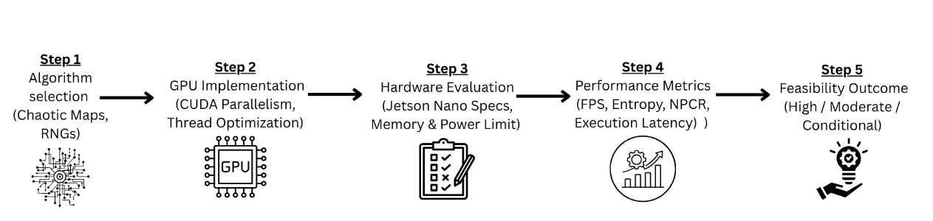
Figure 2-Project Feasibility Framework
The diagram outlines the evaluation flow from algorithm selection through GPU implementation, hardware assessment, and performance metrics leading to an overall feasibility decision for real-time chaotic image encryption on the Jetson Nano. Given Jetson Nano’s 128-core Maxwell GPU and 4 GB memory, real-time chaotic encryption is computationally feasible for 480p–720p imagery using optimized CUDA kernels and shared memory buffers. OpenCV and PyCUDA libraries will support hardware acceleration, while system profiling tools (e.g., tegrastats) will monitor throughput and thermal limits during deployment.

5. References

[1] | E. Berkay, A. Akgul, F. Horasan, G. Abdullah and H. Calgan, “Secure Encryption of Biomedical Images Based on Arneodo Chaotic System with the Lowest Fractional-Order Value,” Electronics.
[2] | E. Berkay and Z. Musayev, “Chaos-based Image Encryption in Embedded Systems using Lorenz-Rossler System,” Research Gate , vol. 5, pp. 153-159, 2023.
[3] | C. Candan and E. M. Sahin, “Implementation of Real-Time Image Encryption Using Chaotic Maps in Embedded Systems,” Journal of Science & Technology , vol. 11, no. 2, p. 11, 2023.
[4] | D. Jiang, Z. Yuan, x. W. Li and L. L. Lu, “Real-time chaotic video encryption based on multithreaded parallel confusion and di usion,” Arxiv, p. 14, 2023.
[5] | H. Ulutas, “A novel memristor-based hyperchaotic hybrid encryption system with DNA for image encryption on the Jetson TX2,” Scientific reports, 2025.
[6] | A. BELAZI, M. TALHA, S. KHARBECH and W. XIANG, “Novel Medical Image Encryption Scheme Based on Chaos and DNA Encoding,” IEEE Access , vol. 7, p. 15, 2019.
[7] | P. Fang, H. Liu and C. Wu, “A Novel Chaotic Block Image Encryption Algorithm Based on Deep Convolutional Generative Adversarial Networks,” p. 22, November 2020.
[8] | R. Parvaz, “A new type of 4D Hybrid Chaos Systems,” 23 january 21.
[9] | V. Patidar and G. Kaur, “A novel conservative chaos driven dynamic DNA coding for image encryption,” p. 29, july 2022.
[10] | B. Zolfaghari and T. Koshiba, “Chaotic Image Encryption: State-of-the-Art, Ecosystem, and future Roadmap,” p. 38, 13 june 2022.

